Number Plate Extraction

(Mini Project on Digital Image Processing)

Submitted By: Submitted To:

ASHUTOSH SHUKLA (13MCA0018) Prof. KAMALAKANNAN J.

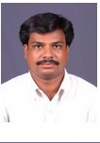PRANAV BHUSHAN (13MCA0096)

Number Plate Extraction

***ABSTRACT***

In Traffic surveillance, Tracking of the number plate from the vehicle is an important task, which demands intelligent solution. In this document, extraction and Recognition of number plate from vehicles image has been done using MATLAB. It is assumed that images of the vehicle have been captured from Digital Camera. Alphanumeric Characters on plate has been Extracted and recognized using template images of alphanumeric characters.

***INTRODUCTION***

Number plate extraction is hotspot research area in the field of image processing. Many of automated system have been developed but each has its advantages and disadvantages. It is assumed that this algorithm worked on images which have been captured from fixed angle parallel to horizon in different luminance conditions. It is also assumed the vehicle is stationary and images are captured at fixed distance.

***METHODOLOGY***

Step by step process is followed for pre processing of image. MATLAB provides all image processing function and toolbox. MATLAB have large library functions and set of tools. Main features of MATLAB are following:

1. It provides advanced algorithm for high numerical computation.

2. Ability to define user define functions and large collection of mathematical functions.

3. For plotting and displaying data, two and three dimensional graphics are supported.

4. Online help is present which is very much helpful for new user.

5. Powerful, effective and efficient matrix and vector oriented high level programming language is provided by MATLAB.

6. Several toolboxes are provides for solving domain specific problems. Some of toolboxes are Image processing toolbox. Fuzzy logic, Digital signal processing toolbox, neural network toolbox etc.

**Steps Involved:**

1. Read the number plate image
2. Convert the RGB (color) image to gray(Intensity)
3. Median filtering to remove noise
4. Dilating the gray image with the structural element
5. Morphological Gradient for edges enhancement
6. Convolution of the image for brightening the edges
7. Thinning the image to ensure character isolation
8. Selecting all the regions that are of pixel area more than 100

Calling of controlling function

**Code for the above steps**:

function numberPlateExtraction

f=imread('sshz1.jpg');

f=imresize(f,[400]); NaNg=rgb2gray(f);

g=medfilt2(g,[3 3]);

se=strel('disk',1);

gi=imdilate(g,se);

ge=imerode(g,se);

gdiff=imsubtract(gi,ge); gdiff=mat2gray(gdiff); gdiff=conv2(gdiff,[1 1;1 1]); gdiff=imadjust(gdiff,[0.5 0.7],[0 1],0.1);

B=logical(gdiff);

er=imerode(B,strel('line',50,0));

out1=imsubtract(B,er);

F=imfill(out1,'holes'); H=bwmorph(F,'thin',1);

H=imerode(H,strel('line',3,90)); .

final=bwareaopen(H,100);

Iprops=regionprops(final,'BoundingBox','Image');

NR=cat(1,Iprops.BoundingBox);

* Function 'controlling' outputs the array of indices of boxes required for extraction of character.
* Extract the binary image corresponding to the indices
* Read the letter corresponding the binary image
* Append every subsequent character in no. Plate variable

***If fail to extract*** the indexes in 'r' this line of error will be displayed Unable to extract the characters from the number plate, the characters on the number plate might not be clear or touching with each other or boundaries

**Code For Above Steps:**

r=controlling(NR);

if ~isempty(r)

I={Iprops.Image};

noPlate=[];

for v=1:length(r)

N=I{1,r(v)}; letter=readLetter(N);

while letter=='O' || letter=='0'

if v<=3 letter='O';

else letter='0'; end

break;

end

noPlate=[noPlate letter];

end

fid = fopen('noPlate.txt', 'wt');

fprintf(fid,'%s\n',noPlate);

fclose(fid);

winopen('noPlate.txt')

else

fprintf('Unable to extract the characters from the number plate.\n');

fprintf('The characters on the number plate might not be clear or touching with each other or boundries.\n');

end

end

**SCREENS:**

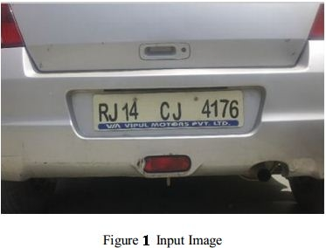

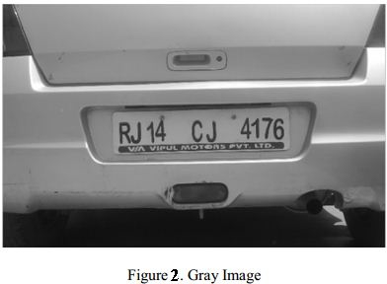

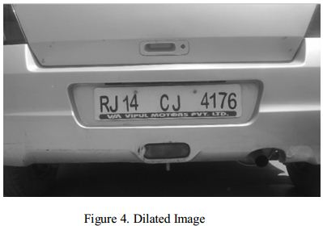

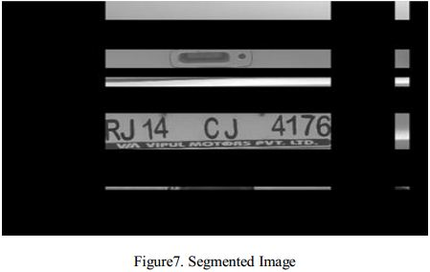

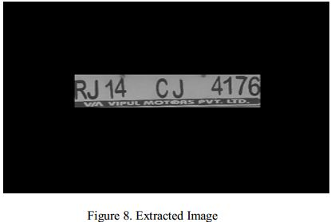

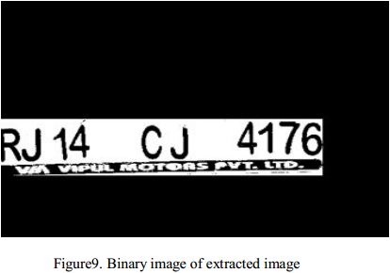

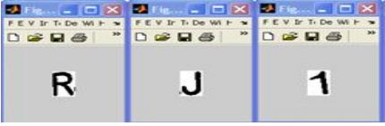

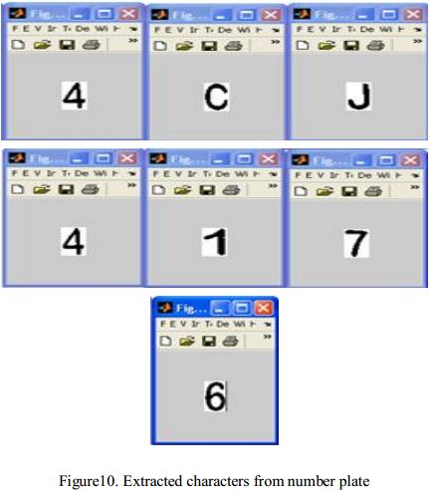

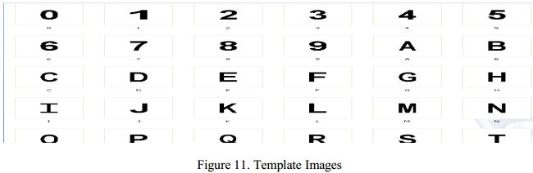

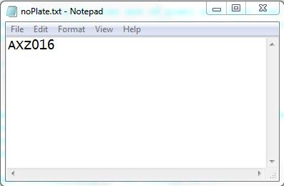

***CONCLUSION:***

This code will read the number plate image and extracts the numbers by applying the above discussed methods and produces the number into a file as text format which can be used in further processes in real world problem.